Template for Evidence(s)
UI GreenMetric Questionnaire

University : ...
Country : ...
Web Address : …

[4] Setting and Infrastructure (SI)
SAMPLE
[4.1] Total area on campus for water absorption besides the forest and
planted vegetation (meter²) (WR.1)

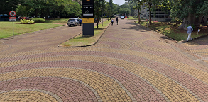 |  | 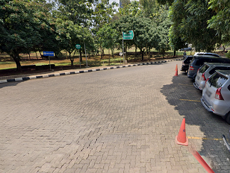
Street 1 | Street 2
Example of Total area on campus for water absorption besides the forest and planted vegetation (Universitas Indonesia, Indonesia)

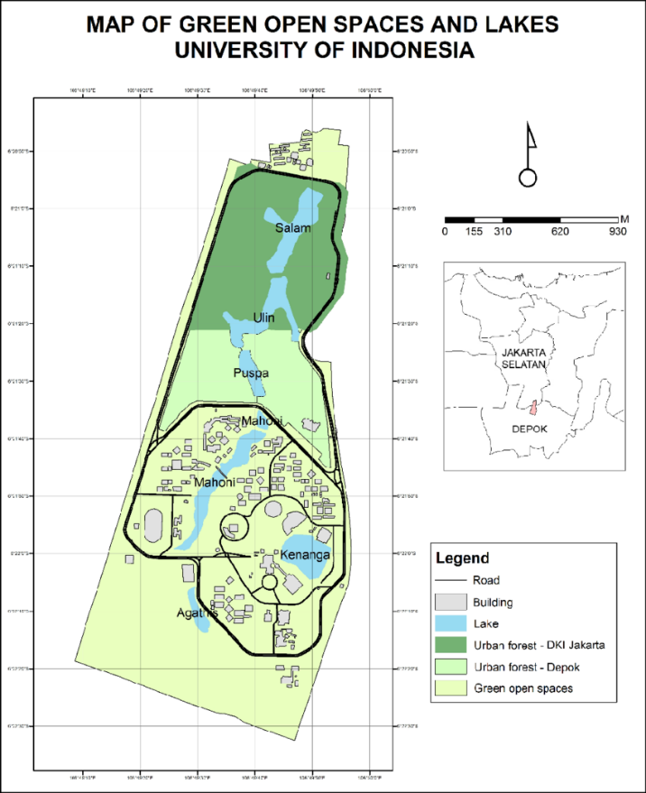
Description:
(Please describe the Total area on campus for water absorption besides the forest and
planted vegetation area in your campus. The following is an example of the description. You can describe more related items if needed.)

The evidence provided may also include maps showing the location, area size, or distribution of facilities relevant to the indicators

Total water absorption area: 128.915m²
Total Area: 454.678 m²
Percentage area: 28%

Additional evidence link (i.e., for videos, more images, or other files that are not included in this file):

